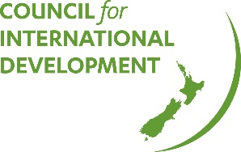
CID Talk, Belinda Gorman
Partnership Brokers Association
Brokering Better Partnerships
Monday 23 July, 2018

Belinda Gorman from Partnership Brokers Association gave a fantastic CID talk last week in Auckland, on how to get your partnerships with other NGOs, government, or business to work well.
You can watch the talk here (apologies to those who missed out on watching it live. We had a technical problem!)
No partnerships are the same. But most share a desire to shift from a "transactional relationship to a collaborative one".
Belinda highlighted some of the key elements to successful partnerships:
- Common purpose
- Share risks and benefits
- Build relationships - people make partnerships, not organisations!
- Make sure the relationships are layered throughout your organisation
- Mutual accountability
- Have courage
- Be prepared to try new things - innovate!
- Start small. Agree to do an activity together and see how that goes.
Always ask yourself:
- Is it good enough?
- Is it fit for purpose
- Does it add value?
If you can't answer yes to all these, then maybe you don't need a partnership, because partnerships are time-consuming and hard work. Don't embark on them if you don't think they'll add value. And don't try and have too many. Less is best. Identify which partnerships can help you make the most change, and put your energy into these.
Real partnerships are rare, and sometimes what we think is a partnership isn't. It might be a funding arrangement or a network. And that's fine. You shouldn't waste time trying to fit a perfectly functional relationship into a 'partnership' model.

